PROMPT -1
I want to build a simple web application to help with creating Change Requests in Project Management.
The idea is straightforward — a user should be able to enter a brief description of the change they want to implement, and the system should automatically generate a well-structured Change Request.

What the website should do:
- Have a clean and simple interface
- Include:
  - A text box where the user can type their requirement (label it: "Enter Change Requirement")
  - A button like "Generate Change"

What should happen in the background:
- When the user clicks the button, the input should be sent to this webhook:
https://myaiapps.app.n8n.cloud/webhook/Change
- This will trigger an n8n workflow.

What the n8n workflow should do:
- Take the user’s input
- Pass it to an AI model
- The AI should generate a complete Change Request with the following sections:
  - Short Description
  - Change Description
  - Impact during implementation
  - Impact (if not executed)
  - Worst Case Scenario
  - Change Justification
  - Implementation Plan
  - Backout Plan
  - Test Plan
- Once generated, the workflow should send the response back to the website.

How the result should appear:
- The output should be displayed clearly on the webpage
- Each section should be easy to read and properly separated
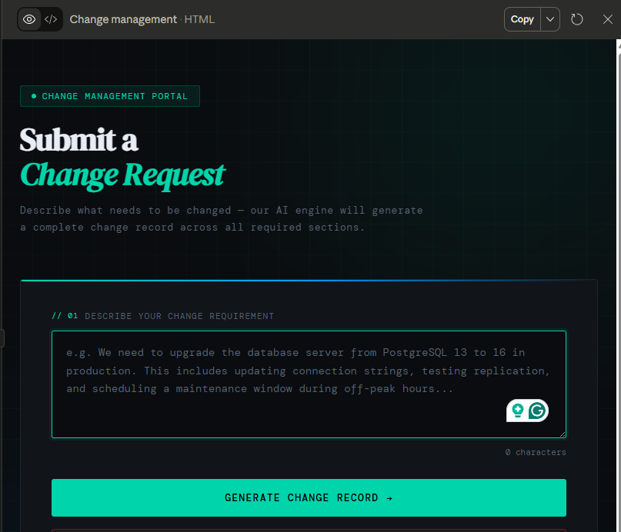

MODIFICATION to Existing PROMPT -2
Please update the existing prompt to include a few additional input fields and use them in the output.

Input fields to add:
- Project Manager Name & Email Address
- Portfolio Manager Name & Email Address
- Downtime required (From Date & Time to To Date & Time)

After submission:
- These details should be included in the generated output as follows:
Impact:
- Add a separate line mentioning downtime, for example:
From [Start Date & Time] to [End Date & Time]
Justification:
- Include:
  - Project Manager Name with Email Address
  - Portfolio Manager Name with Email Address
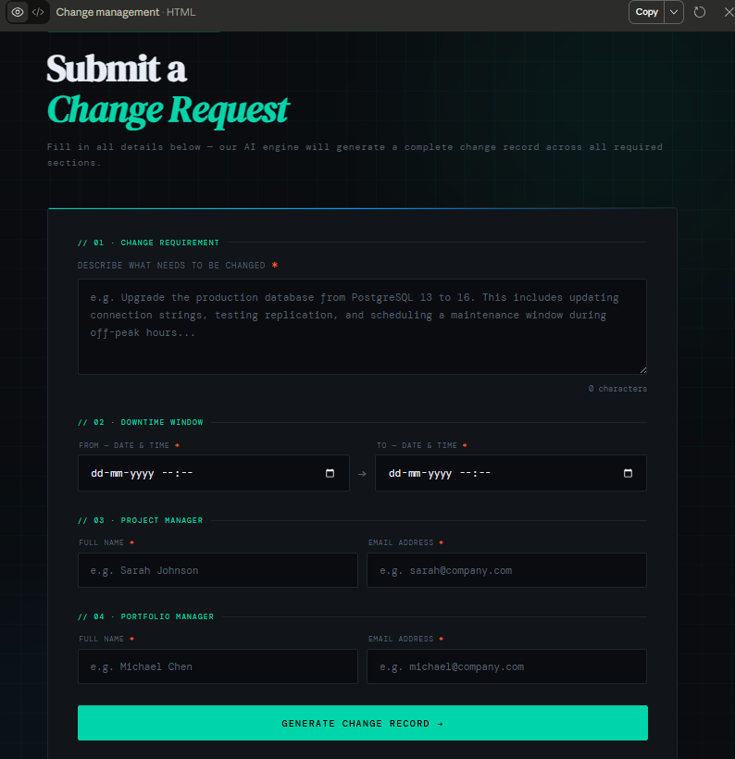

THE N8N WORKFLOW
